**Amazon Timestream**

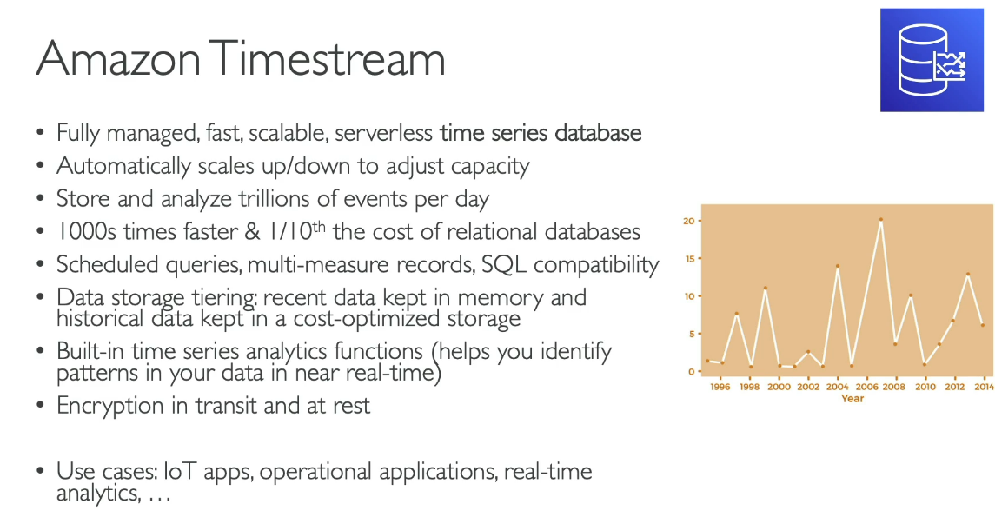

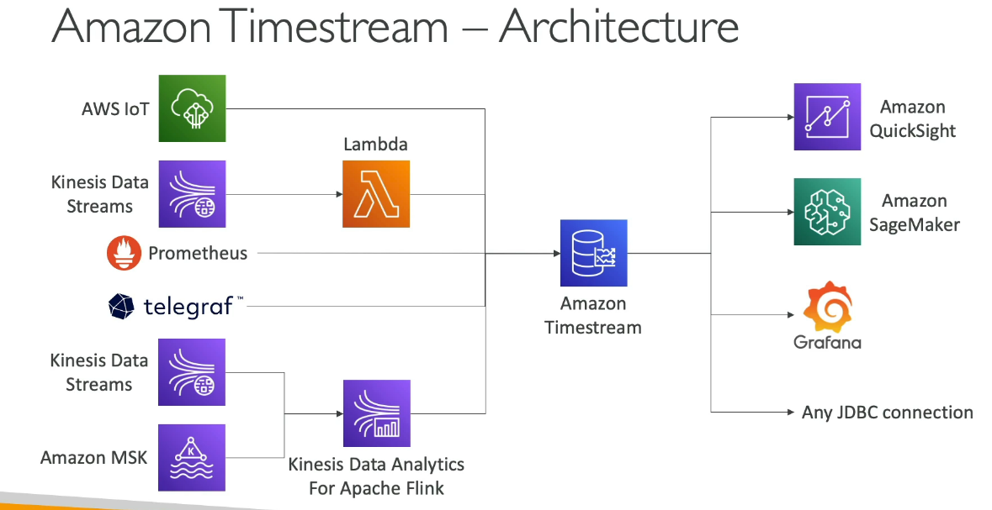

Key concepts:

Time series - A sequence of one or more data points (or records) recorded over a time interval. Examples are the price of a stock over time, the CPU or memory utilization of an EC2 instance over time, and the temperature/pressure reading of an IoT sensor over time.

Record - A single data point in a time series.

Dimension - An attribute that describes the meta-data of a time series. A dimension consists of a dimension name and a dimension value. Consider the following examples:

* When considering a stock exchange as a dimension, the dimension name is "stock exchange" and the dimension value is "NYSE"
* When considering an AWS Region as a dimension, the dimension name is "region" and the dimension value is "us-east-1"
* For an IoT sensor, the dimension name is "device ID" and the dimension value is "12345"

Measure - The actual value being measured by the record. Examples are the stock price, the CPU or memory utilization, and the temperature or humidity reading. Measures consist of measure names and measure values. Consider the following examples:

* For a stock price, the measure name is "stock price" and the measure value is the actual stock price at a point in time.
* For CPU utilization, the measure name is "CPU utilization" and the measure value is the actual CPU utilization.

Measures can be modeled in Timestream for LiveAnalytics as multi-measure or single-measure records. For more information, see Multi-measure records vs. single-measure records.

Timestamp - Indicates when a measure was collected for a given record. Timestream for LiveAnalytics supports timestamps with nanosecond granularity.

Table - A container for a set of related time series.

Database - A top level container for tables.

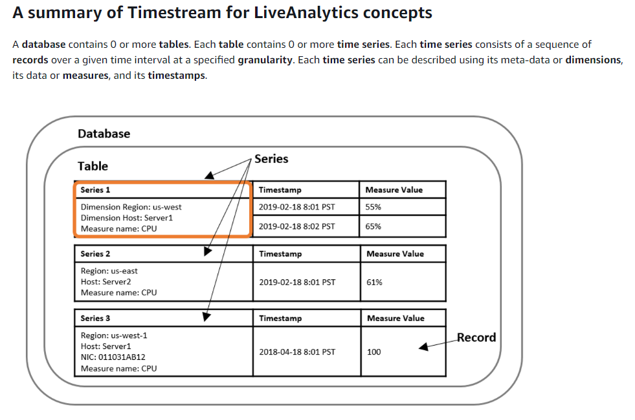

<https://docs.aws.amazon.com/timestream/latest/developerguide/concepts.html>

Example architecture:

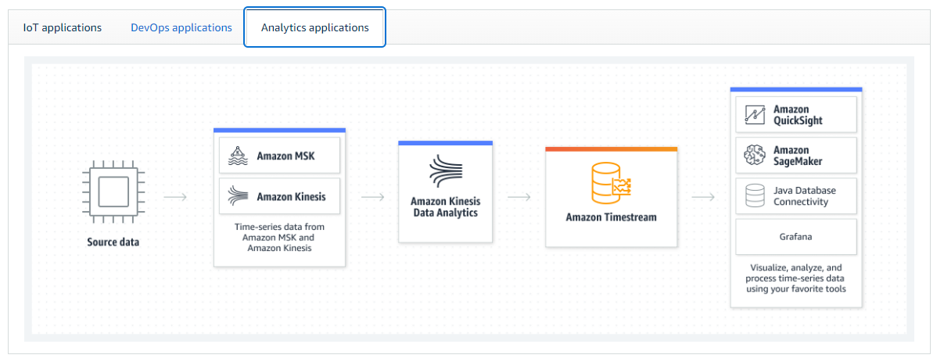

<https://aws.amazon.com/timestream/?nc=sn&loc=1>

To download data in a data Timestream table to an S3 bucket, use the following query:

UNLOAD(select * from "MetricsDB"."EC2")

TO 's3://mytimestreambucketunload/'

WITH(format='CSV')

Tables are downloaded with compression by default. This preserves the data in the Timestream table.

To upload from S3 follow the steps in the console and the batch load tutorial. If you need to create data mapping, copy the data model from the ‘batch load tasks’.

This scheduled query reports the average memory and cpu utilisation rates of EC2 instances per region per day:

select

region,

'averages' as util_average,

bin(time,1d) as per_day,

AVG("MetricsDB"."EC2".memory_utilization) as avg_mem_util,

AVG("MetricsDB"."EC2".cpu_utilization) as avg_cpu_util

from "MetricsDB"."EC2"

group by region, bin(time,1d)

Tutorials:

<https://www.youtube.com/watch?v=7LulhNituEY&list=PLrDJzKfz9AUvCzeI3daKUZjTX96xUEcU-&index=2>

<https://www.youtube.com/watch?v=TzW4HWl-L8s>